Configuration Resource

📝Definition
# Source: AI Source: Provided by: [Data Path: Persons Table -> ID Column: 1, Name_En Column: Motasem Essam] -> From: [ChatGPT] on [1/23/2026]
A Configuration Resource is any centralized set of settings or constants that an application uses to control behavior without hardcoding values. It ensures the application is flexible, maintainable, and consistent.
Think of it as a central control panel for your app’s behavior.

🔑 Key Points
# Source: AI Source: Provided by: [Data Path: Persons Table -> ID Column: 1, Name_En Column: Motasem Essam] -> From: [ChatGPT] on [1/23/2026]
- Holds settings, constants, and environment variables
- Avoids hardcoding values in controllers, services, or models
- Can be global or module-specific
- Often used for themes, API URLs, feature toggles, pagination settings, etc.

🧱 Examples

1️⃣ JavaScript Example
# Source: AI Source: Provided by: [Data Path: Persons Table -> ID Column: 1, Name_En Column: Motasem Essam] -> From: [ChatGPT] on [1/23/2026]
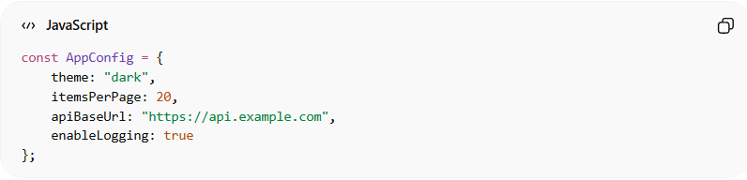
const AppConfig = {
theme: "dark",
itemsPerPage: 20,
apiBaseUrl: "https://api.example.com",
enableLogging: true
};
- AppConfig is a Configuration Resource used throughout the app

2️⃣ Laravel Example
# Source: AI Source: Provided by: [Data Path: Persons Table -> ID Column: 1, Name_En Column: Motasem Essam] -> From: [ChatGPT] on [1/23/2026]
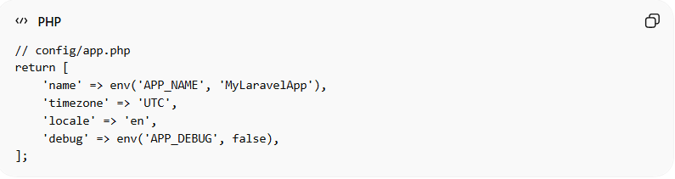
// config/app.php
return [
'name' => env('APP_NAME', 'MyLaravelApp'),
'timezone' => 'UTC',
'locale' => 'en',
'debug' => env('APP_DEBUG', false),
];
- Laravel configuration files are Configuration Resources
- Controllers, Services, and Views can access these via config('app.name')

3️⃣ Environment Variables as Configuration
# Source: AI Source: Provided by: [Data Path: Persons Table -> ID Column: 1, Name_En Column: Motasem Essam] -> From: [ChatGPT] on [1/23/2026]
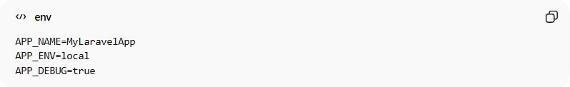
APP_NAME=MyLaravelApp
APP_ENV=local
APP_DEBUG=true
- .env values are dynamic configuration resources
- Keep secrets and environment-specific settings out of code

❌ Bad Example
# Source: AI Source: Provided by: [Data Path: Persons Table -> ID Column: 1, Name_En Column: Motasem Essam] -> From: [ChatGPT] on [1/23/2026]
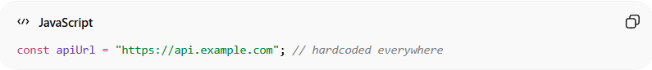
const apiUrl = "https://api.example.com"; // hardcoded everywhere
Problems:
- Difficult to change endpoints
- Breaks DRY principle
- Risk of inconsistencies across modules

✅ Good Example
# Source: AI Source: Provided by: [Data Path: Persons Table -> ID Column: 1, Name_En Column: Motasem Essam] -> From: [ChatGPT] on [1/23/2026]
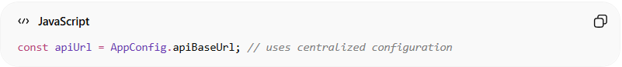
const apiUrl = AppConfig.apiBaseUrl; // uses centralized configuration
- Changes in AppConfig reflect everywhere consistently
- Keeps code clean, maintainable, and flexible

💡 Summary:
# Source: AI Source: Provided by: [Data Path: Persons Table -> ID Column: 1, Name_En Column: Motasem Essam] -> From: [ChatGPT] on [1/23/2026]
A Configuration Resource centralizes settings and constants, reducing hardcoding and improving maintainability.

